**USER MANUAL**

Integration of Industry 4.0 Standards

**Table of Contents**

What is it? 3

What is an Integration of Industry 4.0 Standards? 4

How to interact with the interface? 4

What is an input? 4

How to upload your input? 4

How to produce visualization? 5

How to execute a SPARQL query? 6

How to download an output? 7

How to communicate with developers? 8

# What is it?

This document is a user manual for the project “Integration of Industry 4.0 Standards”. The audience for the document includes both tutors of the Semantic Web Lab and ordinary users. This manual was created with an assumption that the final user is not tech-savvy. Therefore, the description is provided along with illustrations and detailed instructions for every visible part of the project.

For more information regarding the work and technical documentation, you can visit the GitHub webpage of project. (<https://github.com/IntegrationI40StandardsSemLab/Integration-I4.0>).

# What is an Integration of Industry 4.0 Standards?

I 4.0 or Industry 4.0 is a combination of production methods with state-of-the-art information and communication technology. In the world of Industry 4.0, people, machines, equipment, logistics systems and products communicate and cooperate with each other directly.

Our project is a web-based tool that uses RDF(S) vocabularies for integrating instances of such standards as AutomationML (and OPCUA) into one piece.

# How to interact with the interface?

## What is an input?

An input for our application can be .xml, .aml or .opcua files that consist of the data in AutomationML or OPCUA format. The file can be of size up to 5 Gb and have to be error-free in order to produce a relevant output.

## How to upload your input?

In order to upload your files, first you have to open the web page “Project”:

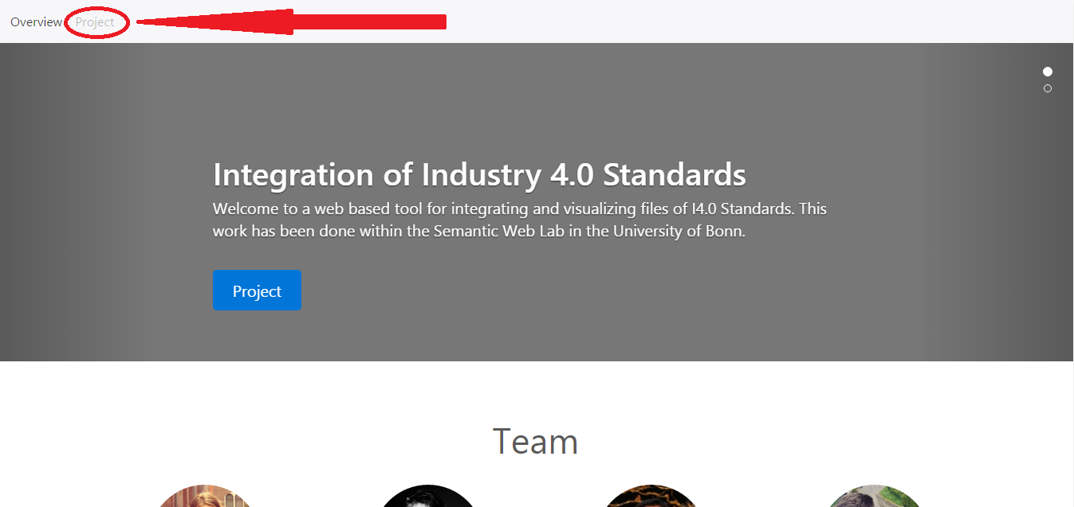

After that, the form for uploading will appear:

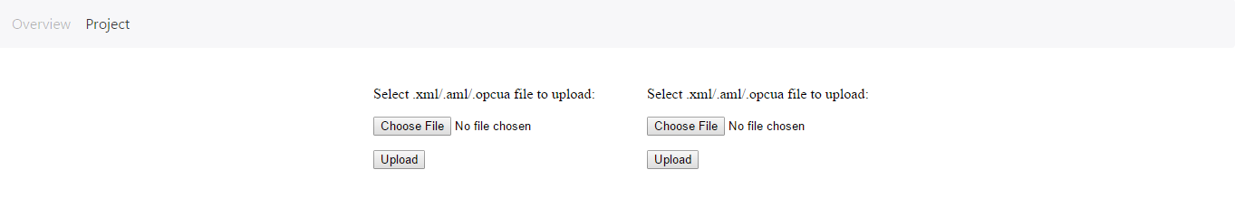

Clicking the button “Choose file” you will be asked to highlight one of the files you want to upload to the application. If the files has been already uploaded or it is of unknown format a warning will appear:

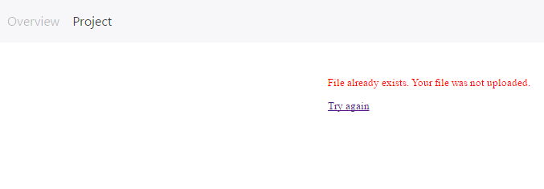

## How to produce visualization?

After uploading the file, you are able to look at the visualization of the data:

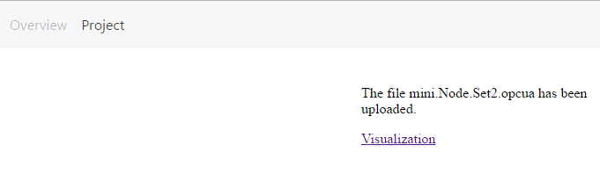

Clicking on the link you will be redirected to the web page with the collapsable tree that represents uploaded data:

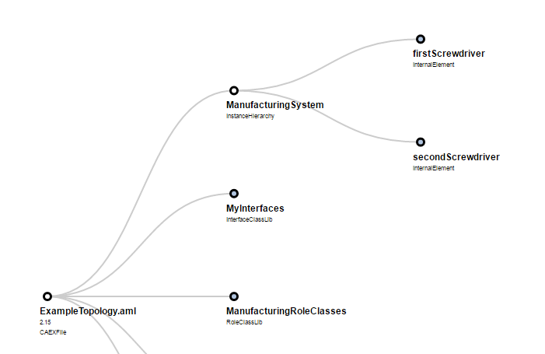

The whole data is divided into 5 main parts – InstanceHierarchy, InterfaceClassLib, RoleClassLib, SystemUnitClassLib and Extra (contains all other information). In order to expand the node and go to the next level you should click on the circle above the name of the node. If the circle is blue – it means that the node is expandable, otherwise – it is not.

## How to execute a SPARQL query?

After uploading both files that should be integrated, clicking on the button “Query Zone” will lead you to the form for inputting a SPARQL query:

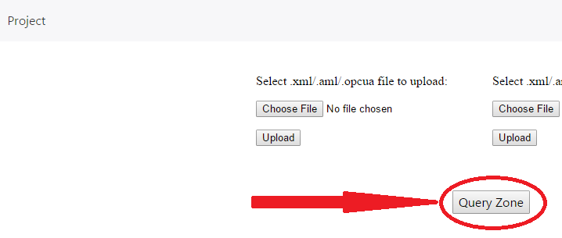

It may help you to find any instances you want in a newly generated file. To read more about SPARQL and its capabilities you can visit the following web page <https://www.w3.org/TR/rdf-sparql-query/>.

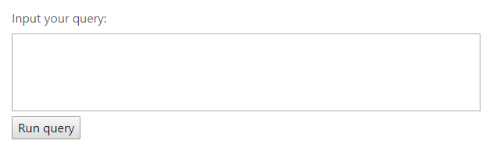

## How to download an output?

With accepting you to execute SPARQL queries, the web page will offer to download the file:

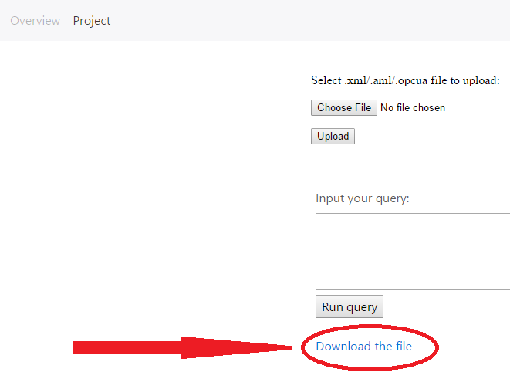

# How to communicate with developers?

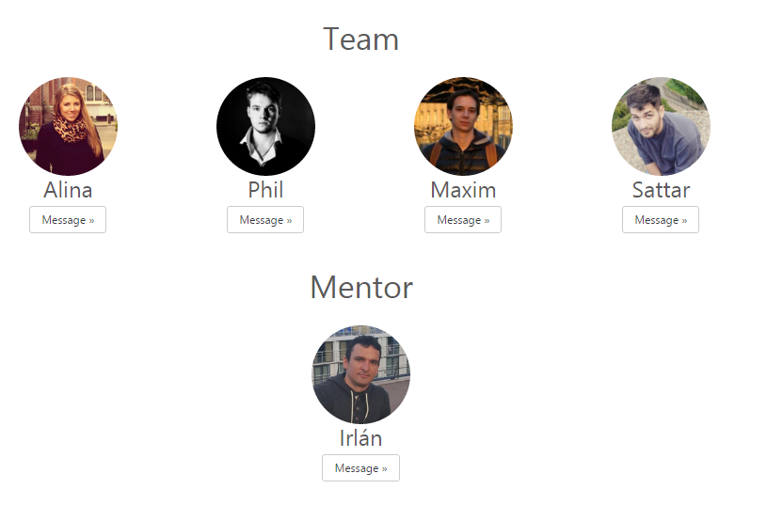

In case of finding any bugs, mistakes in the projects or inability of working with the functionality, our group kindly asks you to contact one of the group members:

Alina Arunova – [alinkamalinkakalinka@yandex.ru](mailto:alinkamalinkakalinka@yandex.ru)

Philipp Matyash- [matyash.phil@gmail.com](mailto:matyash.phil@gmail.com)

Maxim Maltsev – [maltsevmn@ya.ru](mailto:maltsevmn@ya.ru)

Sattar Rahimbeyli - [sattari4@hotmail.com](mailto:sattari4@hotmail.com)